**ITS 26000 – Applied Database Tech**

**Lab 03 – (100 points)**

**Questions. KimTay Pet Supplies: Module(Chapter) 2: Q - 2, 3**

1. Load the scripts in Labs🡪Database Scripts into your DBMS, and paste a screenshot in your lab report to show the two databases (KimTay Pet Supplies & StayWell Student Accommodation) are ready to use. (20 points)

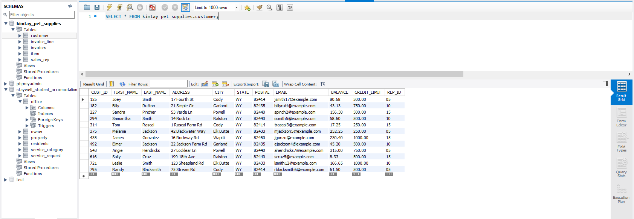

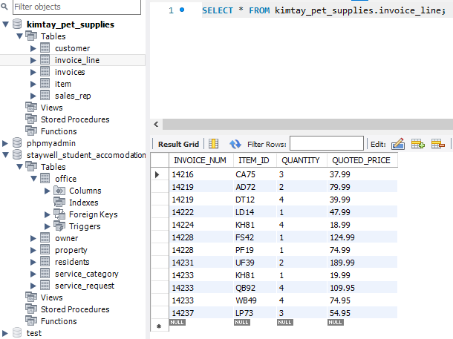

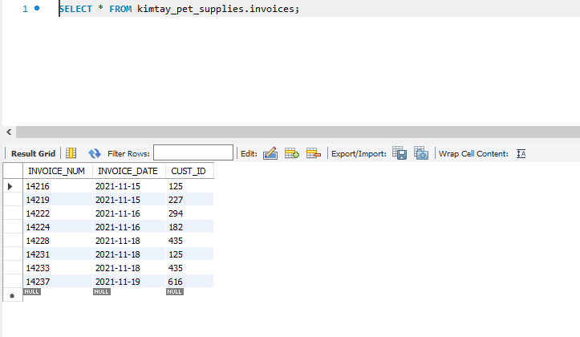

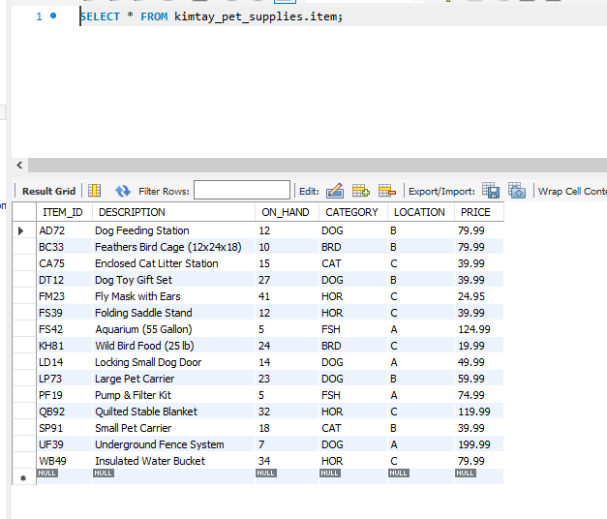

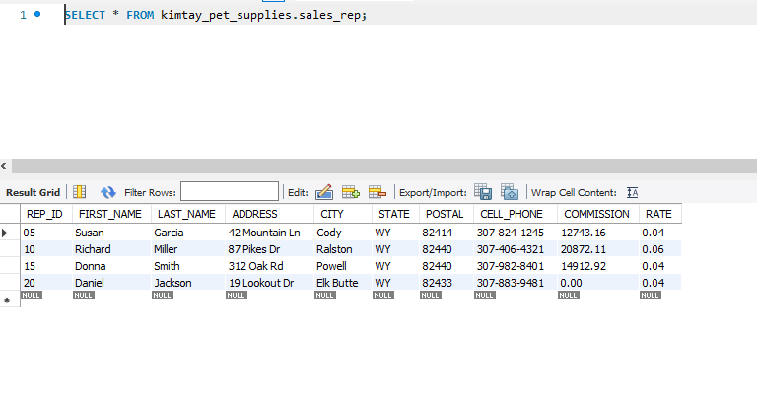

**Staywell_ Student_accomodation**

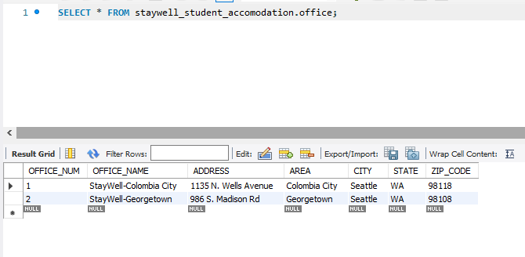

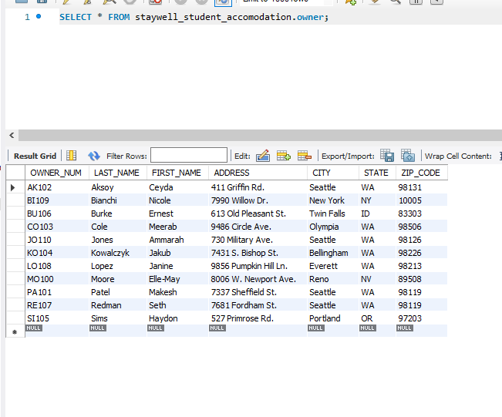

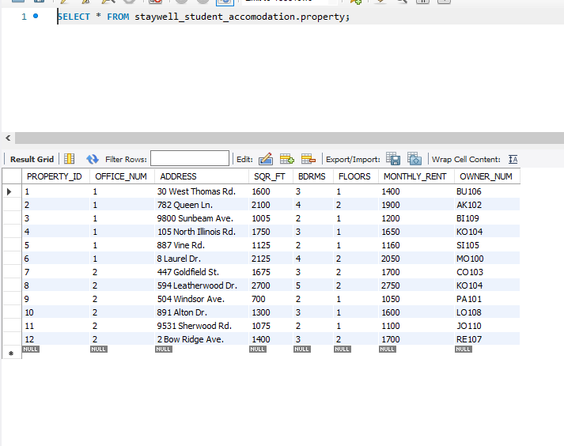

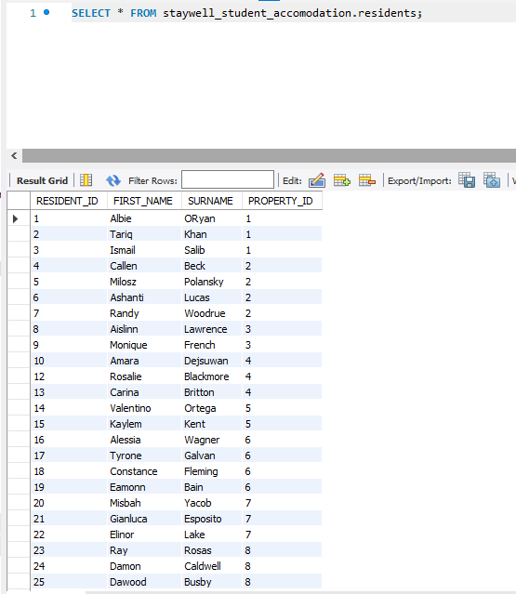

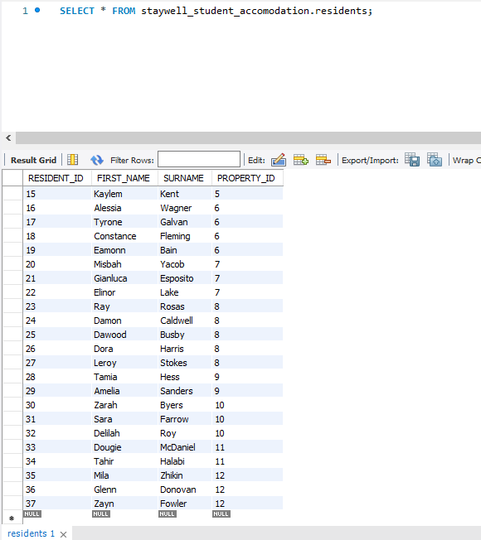

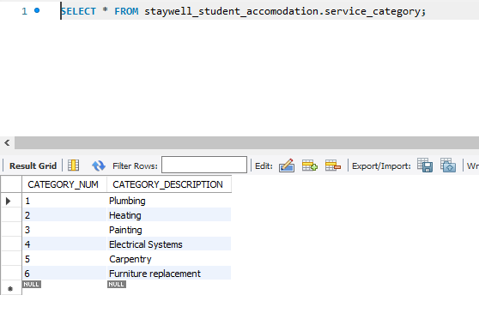

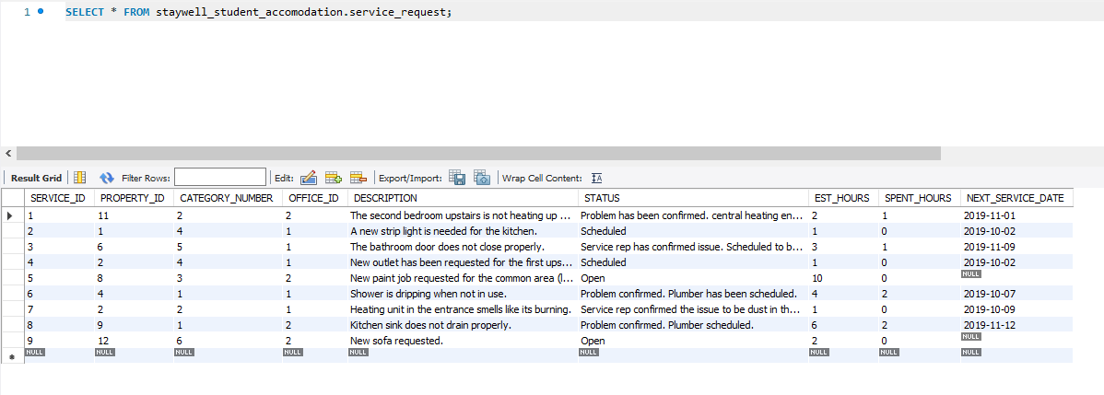

1. Indicate the changes (using the shorthand representation) that you would need to make to the original KimTay Pet Supplies database design to support the following requirements. There is no relationship between customers and sales reps. When a customer places an order, any sales rep can process the order and create the invoice. On the invoice, you need to identify both the customer placing the order and the sales rep responsible for the invoice. Draw an E-R diagram for the new design. (40 points)

Changes I made :

* 1. Dropping the Rep_ID from Customer table

(CUST_ID, FIRST_NAME, LAST_NAME, ADDRESS, CITY, STATE, POSTAL, EMAIL, BALANCE, CREDIT_LIMIT)

* 1. Adding the Rep ID to the invoice table:

Invoices(INVOICE_NUM, INVOICE_DATE, *CUST_ID, REP_ID*)

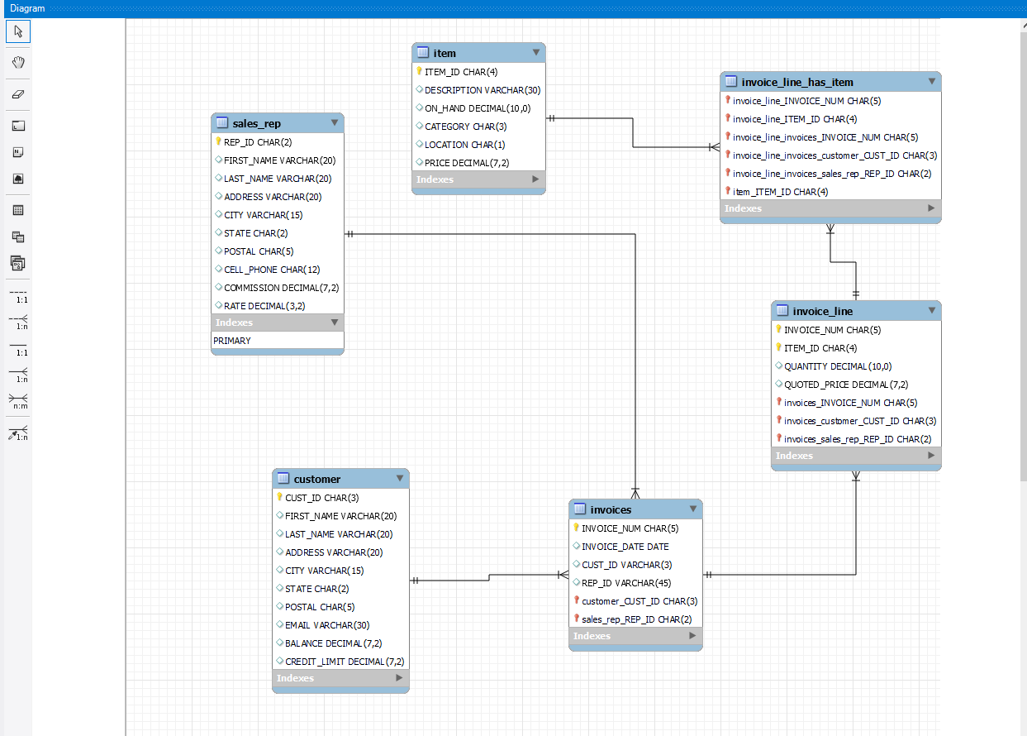

1. Indicate the changes (using the shorthand representation) that you would need to make to the original KimTay Pet Supplies database design in the event that the original Requirement 3 is changed as follows. For an item, store the item’s ID, description, category, and price. In addition, for each location in which the item is located, store the value of the location, the description of the location, and the number of units of the item stored in the location. Draw an E-R diagram for the new design. (40 points)

Customer( Cust_ID, First_name, last_name, address, city, state, postal, email. Balance, credit_limit, rep_id)

Sales_rep(rep_id, first_name, last_name, address, city, state, postal, cell_phone, commission, rate)

Item(Item_id, description, category, price)

Location(Location_id, value_of_location, description_of location, on_hand)

Location_of_Item(Location_id, Item_id)

Invoices(Invoice_num, Invoice_date, cust_id)

Invoice_line(Invoice_num, Item_id, quantity, quoted_price)

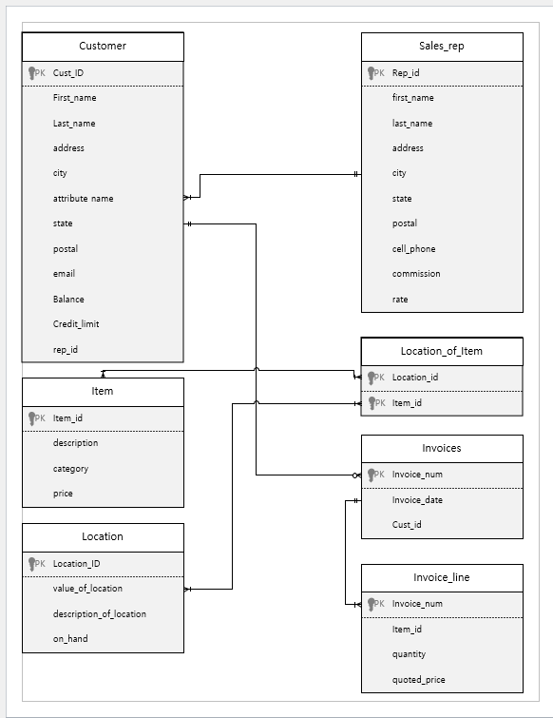

**Deliverables:** Document Report with question and answer (either word or pdf file) need to be uploaded into Brightspace in one submission